Shop Nest Store - Dashboard Report

This report presents a comprehensive analysis based on the Power BI dashboard developed for Shop Nest. Each section below corresponds to a specific business question, with supporting visualizations and insights.

**Project Title:** Shop Nest Store Dashboard  
**Prepared By:** Sachin  
**Tools Used:** MySQL, Power BI, Excel, Python (For creating database and upload data)  
**Date:** 12/05/2025

### Objective

The primary goal of this dashboard is to provide a **comprehensive analysis of product orders** stored in the MySQL database. The dashboard enables stakeholders to monitor key metrics such as order volume, revenue trends, customer behaviour, payment methods, and product category performance — helping in data-driven decision-making.

## Complete Dashboard

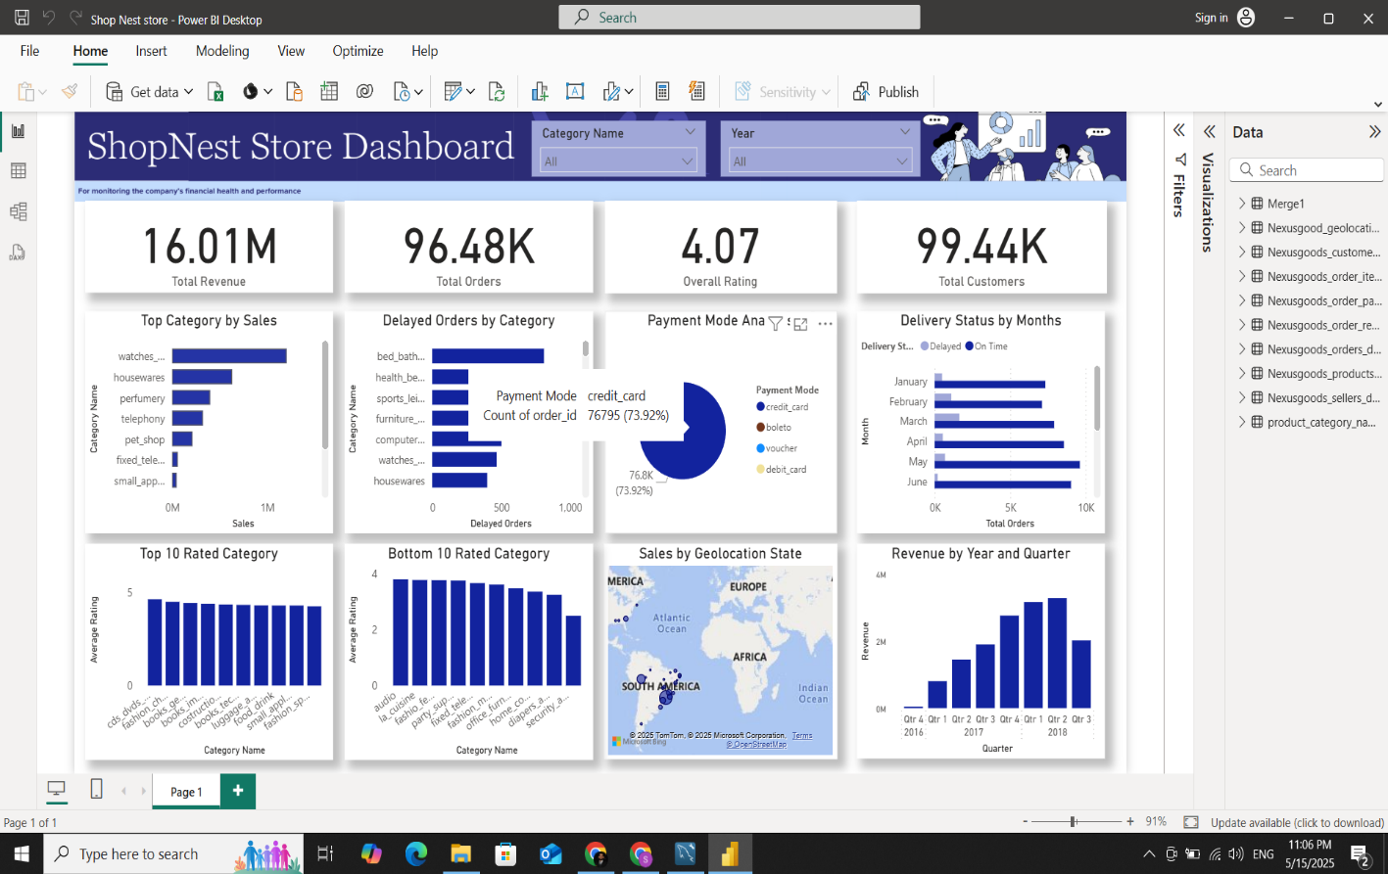

## Data Overview

| **Attribute** | **Description** |
| --- | --- |
| Order_ID | Unique identifier for each order |
| Customer_ID | Identifier for the customer placing the order |
| Product_Category | Category name of the ordered product |
| Order_Date | Date when the order was placed |
| Delivery_Date | Expected or actual delivery date |
| Delivery_Status | Status (e.g., Delayed, On Time) |
| Payment_Method | Mode of payment (e.g., Debit Card, Credit Card, Voucher, Bolete) |
| Order_Amount | Total order value |
| Shipping_Cost | Delivery charges applied |
| Discount_Applied | Discount value or percentage |
| Final_Amount | Net payable amount after discount and shipping |
| Customer_Rating | Feedback rating provided by the customer |
| Delivery_City | City where the order was shipped |

## Key Insights & Metrics

**1. Total Orders & Revenue**

* **Total Orders Placed:** 96.48K
* **Total Revenue (Final Amount):** $16.01M
* **Overall Customer Rating:** 4.07 / 5
* **Total Unique Customers:** 99.44K

**2. Top Category by Sale**

* **Visualization Type:** Clustered Bar Chart
* **Details:**
  + **Y-Axis:** Category Name
  + **X-Axis:** Total Sales Amount
  + **Insight:** Categories are sorted in descending order to easily identify top-selling product segments.

**3. Delayed Orders by Category**

* **Visualization Type:** Clustered Column Chart
* **Details:**
  + **Y-Axis:** Category Name
  + **X-Axis:** Number of Delayed Orders
  + **Insight:** Highlights which product categories experience the most delivery delays.

**4. Payment Mode Analysis**

* **Visualization Type:** Pie Chart
* **Details:**
  + **Segments:** Credit Card, Debit Card, Boleto, Voucher
  + **Metrics Shown:** % Usage and Revenue by Mode
  + **Insight:** Helps understand customer payment preferences and their revenue contribution.

**5. Delivery Status by Month**

* **Visualization Type:** Clustered Bar Chart
* **Details:**
  + Shows monthly comparison of **Delayed** vs **On-Time** orders.
  + **Insight:** Helps identify months with delivery performance issues.

**6. Top Rated Categories**

* **Visualization Type:** Stacked Column Chart
* **Details:**
  + **X-Axis:** Top 10 Categories
  + **Y-Axis:** Average Customer Rating
  + **Insight:** Highlights categories most appreciated by customers.

**7. Bottom Rated Categories**

* **Visualization Type:** Stacked Column Chart
* **Details:**
  + **X-Axis:** Bottom 10 Categories
  + **Y-Axis:** Average Customer Rating
  + **Insight:** Identifies areas needing improvement in product quality or service.

**8. Total Sales by State**

* **Visualization Type:** Geo Map
  + **Insight:** Visual representation of revenue contribution by each state. Useful for geo-targeted strategies.

**9. Revenue by Year and Quarter**

* **Visualization Type:** Stacked Column Chart
* **Details:**
  + **X-Axis:** Yearly Quarters (Q1, Q2, Q3, Q4)
  + **Y-Axis:** Revenue
  + **Insight:** Tracks seasonal or quarterly revenue patterns.

**10. Interactive Slicers**

* **Slicers Added:**
  + **Category:** Dropdown filter
  + **Year:** Range selector
  + **Insight:** Enables dynamic analysis across visuals by category and year range.

**MySQL Database Created:**Designed and implemented a MySQL database to structure the raw data for efficient querying. Utilized SQL for performing quick analysis and extracting key insights to support dashboard development.

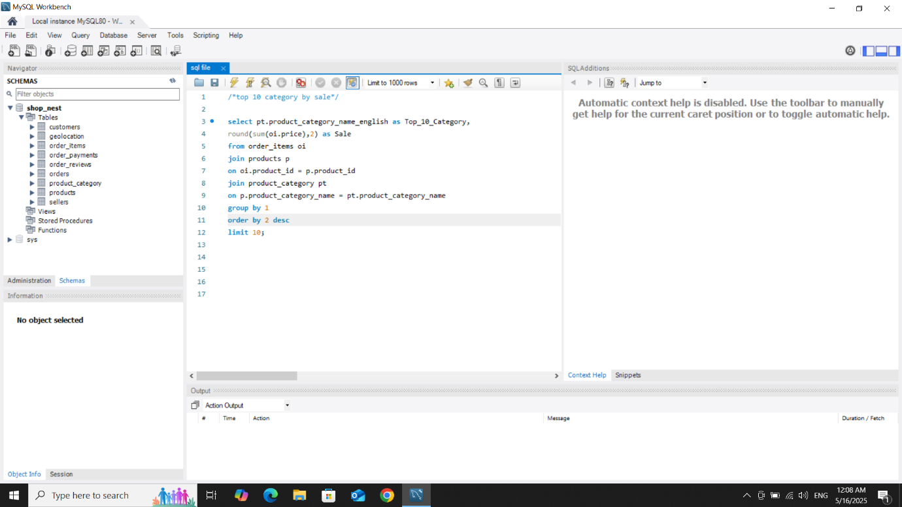

**Python Integration:**Utilized Python to streamline and automate the process of uploading large datasets into the MySQL database, ensuring faster and more efficient data handling.

